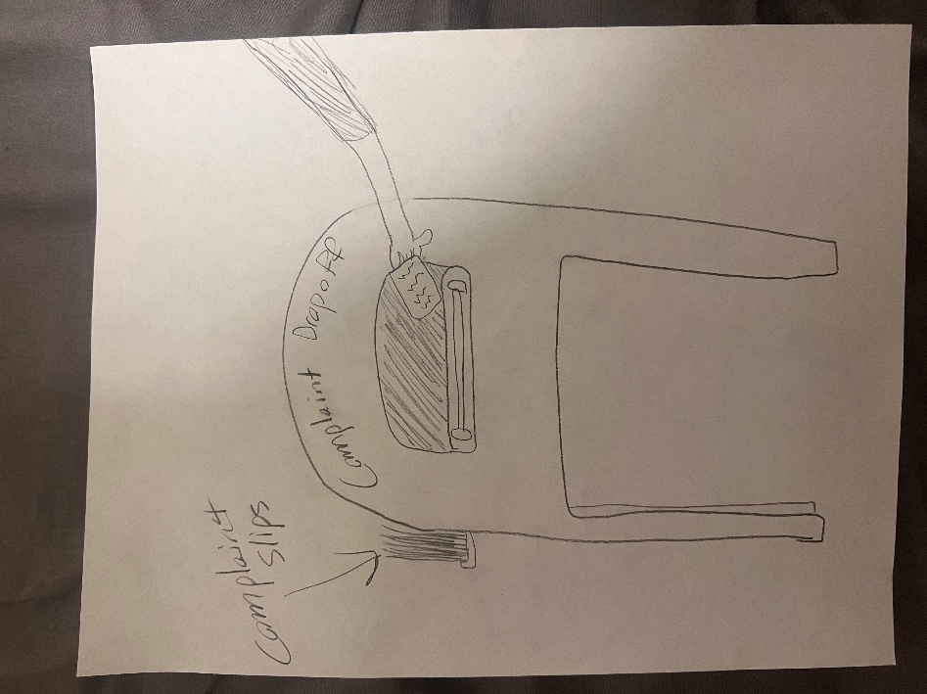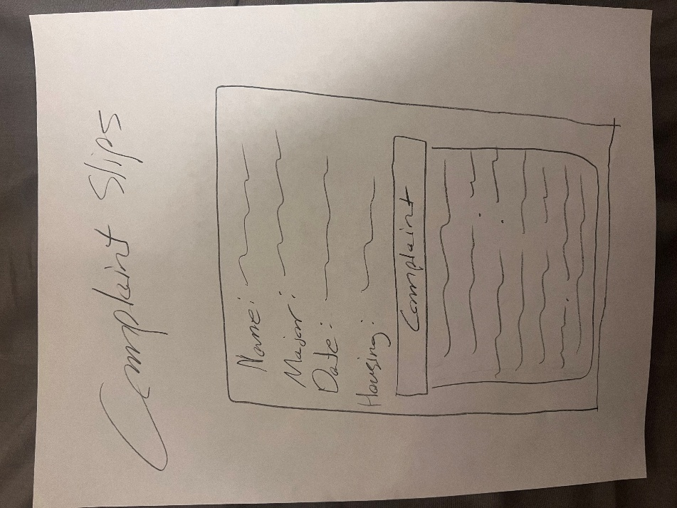
A physical complaint system that involves writing on a card and dropping it into any of the multiple complaint drop off points.
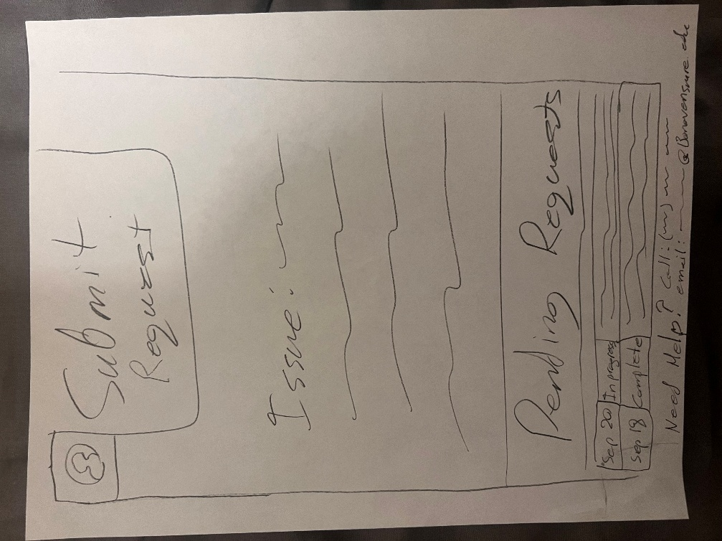
An app version of a complaint submission.
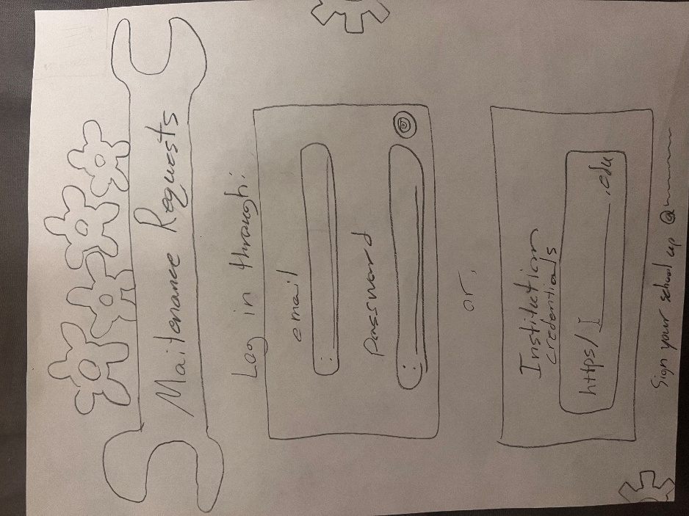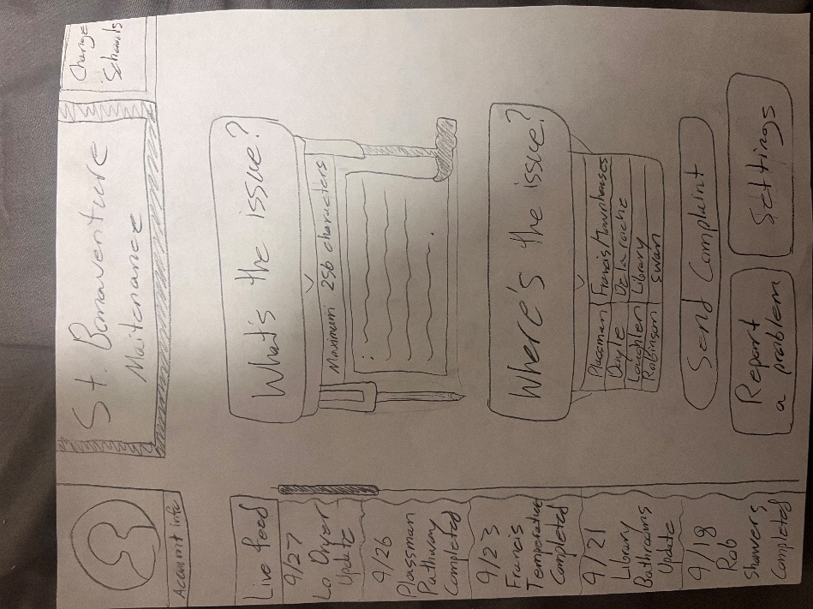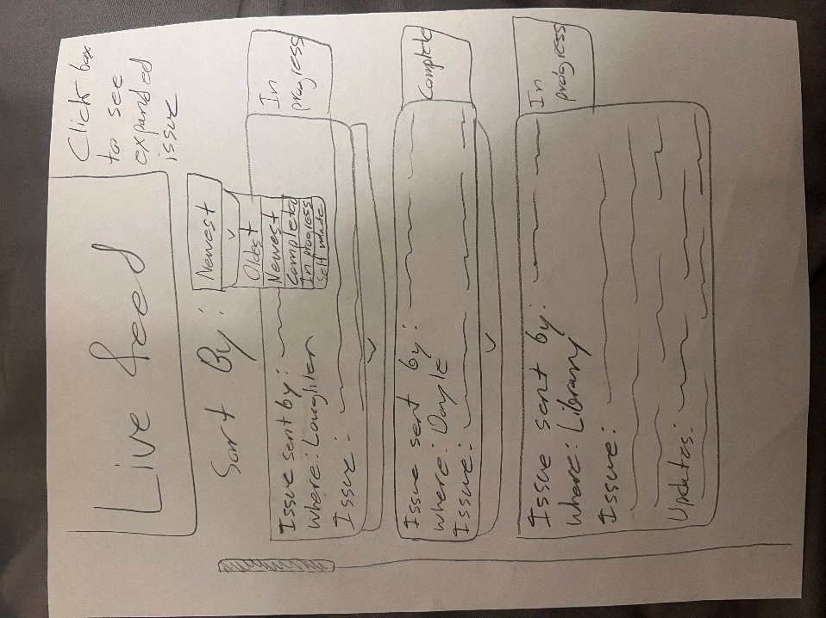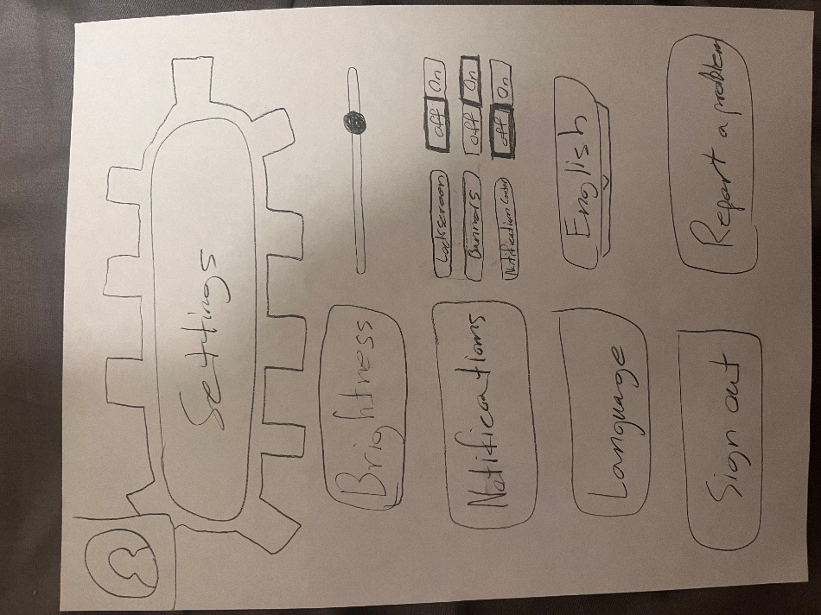
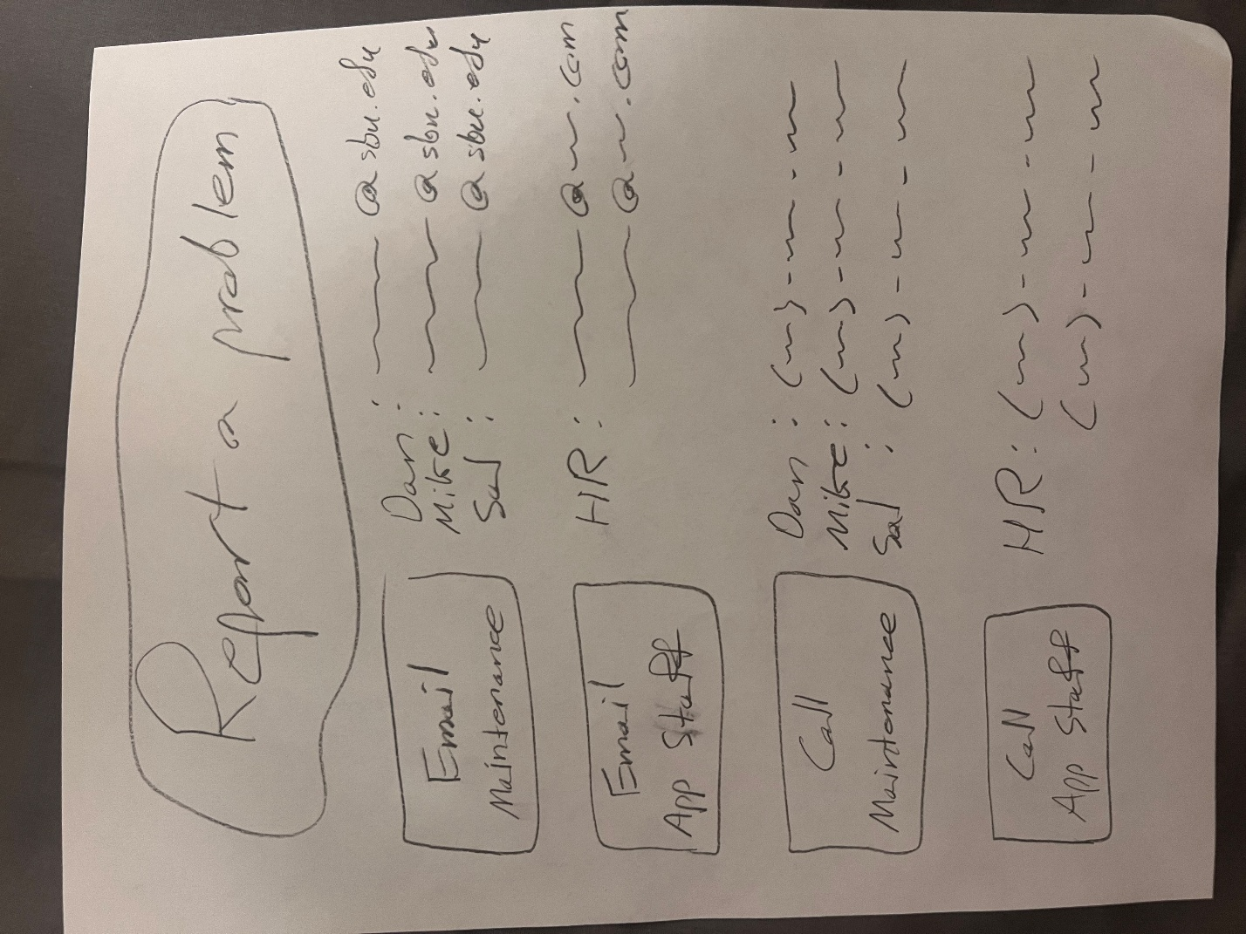
The 5 topmost pictures are the prototypes I had people use. It included a sign in page, main page, live page, settings and a contact list.

Complete evaluation plan:
For a more fleshed out plan, I wanted to make an application for phones. A common complaint in my interviews that putting in an FSR was extremely confusing and the app to see updates was useless. By making an actual app with a nice UI and more functions, people can download it and easily report their problems. Also, by putting a link to the app on the sbu website, people won’t have to search far and wide to access it.
Another of the main points from my interviews was that there was no way to access concrete information on the progress of issues. In one interview, someone mentioned that they had been waiting since the start of the semester with no update on the issue with his washer. Due to this, I wanted to make a system where all maintenance updates would be available to be seen by anyone using the app. Even if the update isn’t on your specific problem, it will allow you to see that the maintenance team is still making progress on campus. This will also keep them motivated to stay on track.
Through having multiple peers look through my final idea, I was told that there was a lot of clutter on my app idea. I was told that while some of the features made sense, there was too much going on most of the pages. So, I had the idea of making slightly more buttons that go to separate pages. This would keep the design but make it more breathable.
I was reminded during my peer evaluation that the only screen that one can interact with is the page directly after logging in. To make it more interactive, I want to make a page that shows a list of all problems that the user has submitted themselves. This will keep people’s thoughts more organized. This also prompted me to make a draft section. With a draft section, someone can come back to a prompt that they were on the fence about submitting. This gives people more lenience on what issues they want to bring up.

Reflection:
I found this project particularly difficult. Typically, in computer science classes I focus on the logical side of coding. I felt like I didn’t know where to start with how much freedom we had in making our designs. The beginning designs I had weren’t too revolutionary.
At the beginning I was thinking of physical ideas so I made slips and a drop off area, but then I imagined that it would be too much work for people to do. Students would have to go to a drop off location, fill out a slip, and then still have no idea when their issue will be fixed. This made me think that an actual app would be a better idea, since it would be more efficient and have updates.
Then I made a simple idea for an app. I used online references for the baseline designs I needed and explored what I would want it to look like. While creating it, I kept adding more features that I thought would be helpful for users. This in turn made me realize through peer review that I added way too many features and visual aspects. I then had to hunker down and leave in the essentials while taking out the unnecessary parts.
Overall, this lab showed me how much goes into the actual designs of applications and systems. Peer review also serves a larger purpose in these processes.

